GQM+Strategies
Use-Case-Realization Specification: <Use-Case Name>Create new simple metric

Version 1.0

Revision History
Date | Version | Description | Author
12/02/2014 | 1.0 | Initial Version | Tiziano Campili, Marco Ferrari

Table of Contents
1. Introduction 4
1.1 Purpose 4
1.2 Scope 4
1.3 Definitions, Acronyms, and Abbreviations 4
1.4 References 4
1.5 Overview 4
2. Class Diagrams 4
3. Activity diagrams 7
4. Sequence Diagrams 9

Use-Case-Realization Specification: <Use-Case Name>Create new simple metric

Introduction

Purpose

This document represents how the Create new simple metric use case will be implemented in terms of collaborating objects.

Scope

This document describes the realization specification on Create new simple metric use case.

Definitions, Acronyms, and Abbreviations

Refer to Glossary Document.

References

- Glossary
- Use Case – Create new simple metric

Overview

This document contains the Use Case Create Metric class diagram and collaboration diagrams.

Class Diagrams

The figure below shows an analysis class diagram for the realization of the Create new simple metric use case. Notice the use of model-view-control stereotypes to represent analysis classes, and the use of data access object (DAO). The DAO is an object that provides an abstract interface to some type of database or other persistence mechanism by mapping calls to the persistence layer, DAOs provide some specific data operations without exposing details of the database. In conclusion, note the use of the pattern facade, through the use of business object facade. The Facade is an object that provides a simplified interface to a larger body of code, such as a class library or in our case one or more Data Access Objects.

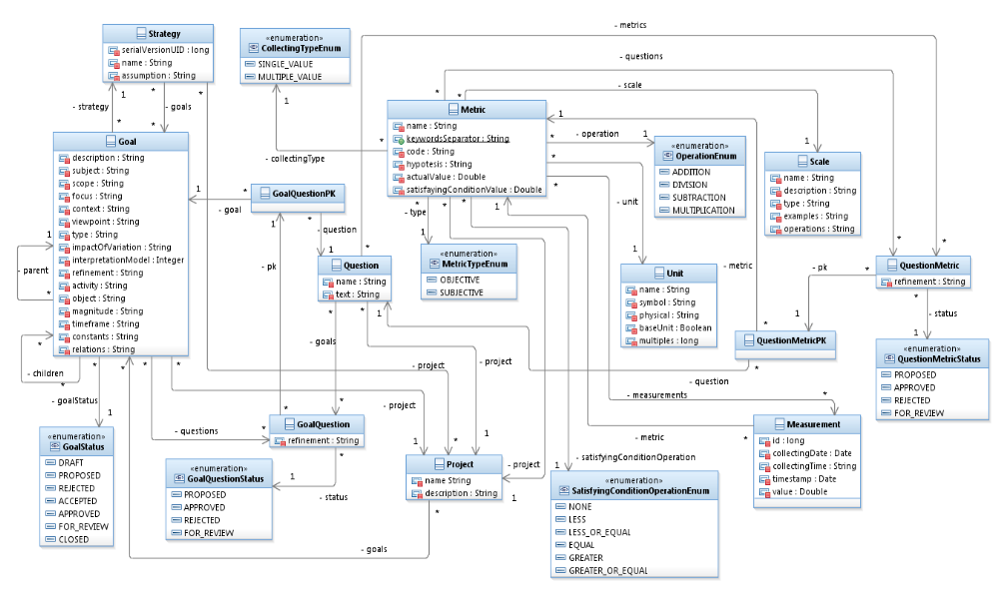
Figura 1. Model Class Diagram

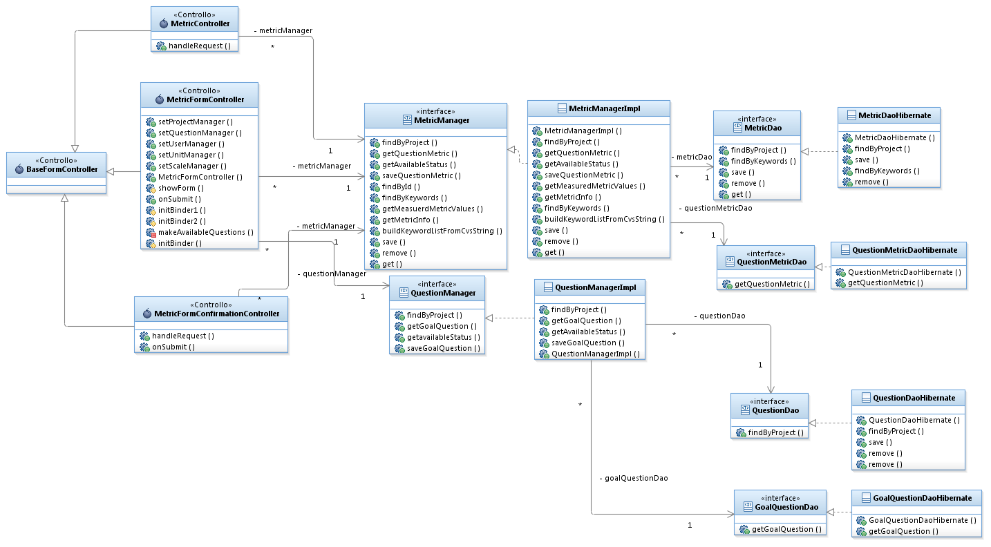
Figura 2: insert new simple metric class diagram

Activity diagrams
This section show activity diagrams.
Activity diagrams depict organizational and computational aspect of processes.
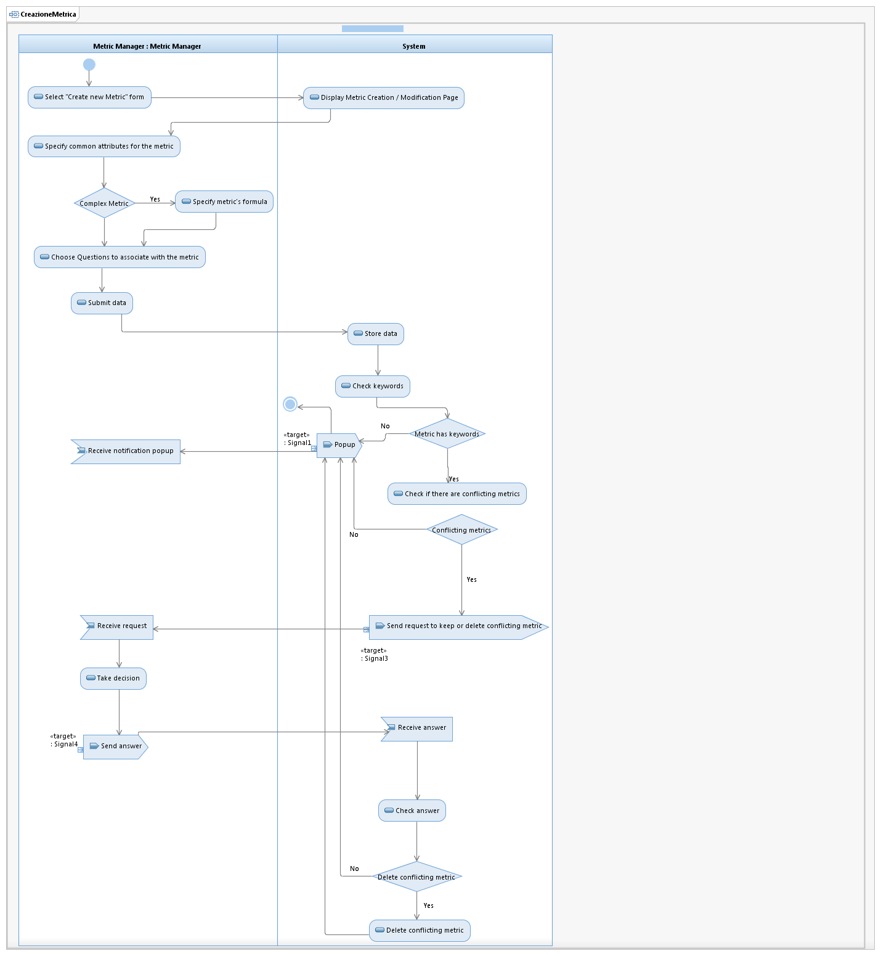
Figura 3: insert new simple metric activity diagram

Sequence Diagrams
This section shows sequence diagrams depicting its participating objects and their interactions.
Sequence diagrams show the explicit sequence of messages and are better when it is important to visualize the time ordering of messages.

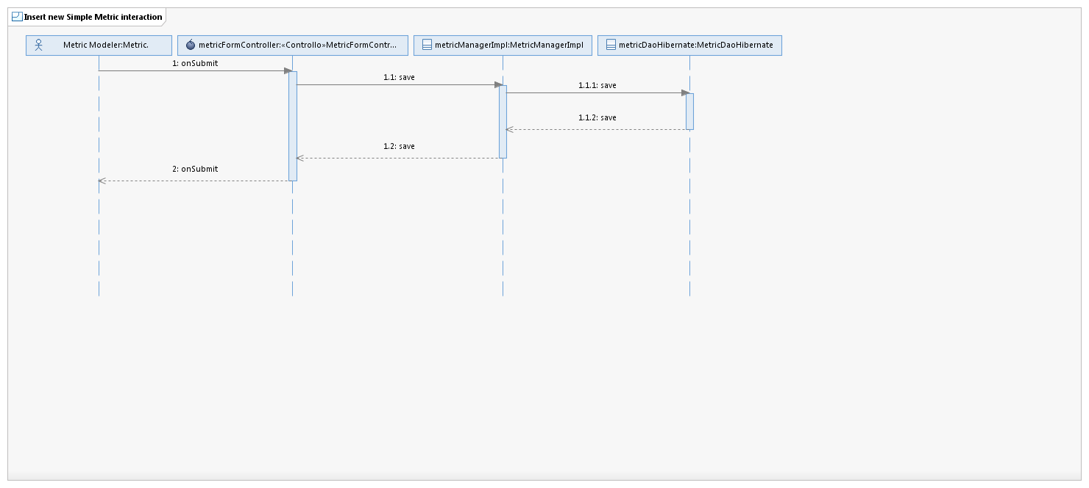
Figura 4: insert new simple metric sequence diagram
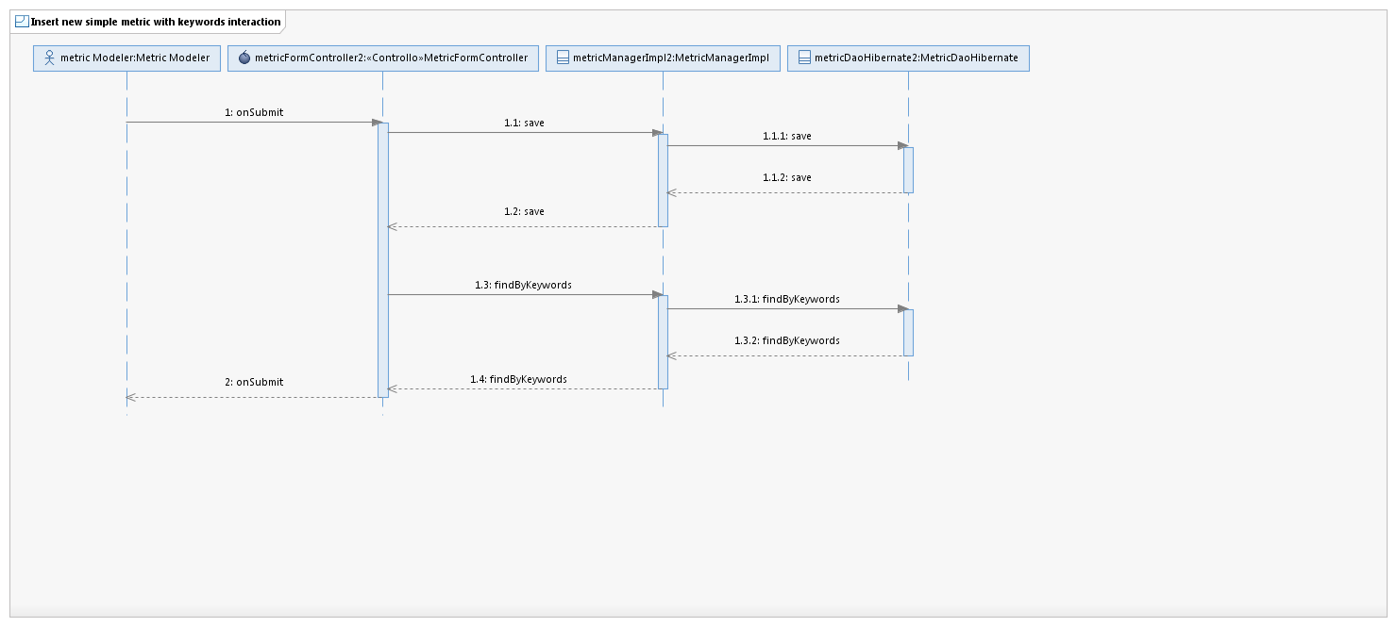
Figura 5: insert new simple metric with keywords sequence diagram
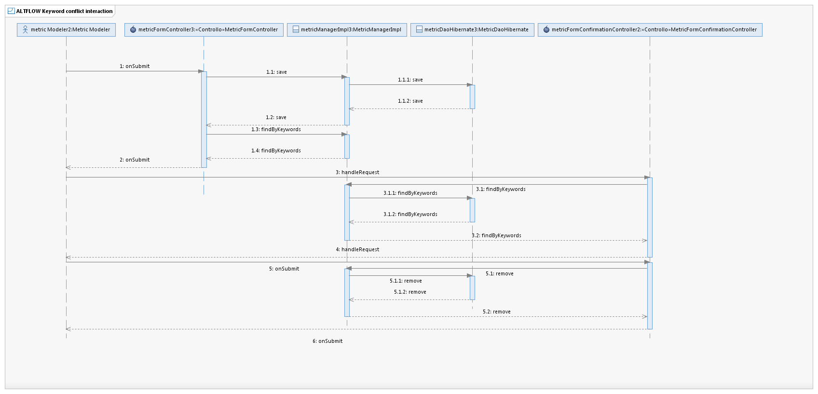
Figura 6: (Alternative flow) insert new simple metric with conflicting keywords

